**Report**

|  |  |
| --- | --- |
| Date | 6 October 2025 |
| Team ID | xxxxxx |
| Project Name | Predicting Plant Growth Stages with Environmental and Management Data Using Power BI |
| Maximum Marks | 5 Marks |

A report is a comprehensive document that provides a detailed and structured account of data analysis, findings, and insights. It is typically used for in-depth analysis, documentation, and communication of results. Reports are suitable for a diverse audience, including decision-makers, analysts, and stakeholders who need a comprehensive understanding of the data.

Designing a report in Power BI involves connecting to data sources, creating visualizations like charts and graphs, customizing their appearance and interactivity, organizing them logically on the canvas, formatting elements for consistency and clarity, and optionally creating dashboards for a summarized view. Throughout the process, it's essential to consider the audience's needs and ensure the report effectively communicates insights from the data. Finally, iterate based on feedback to continually improve the report's design and usefulness.

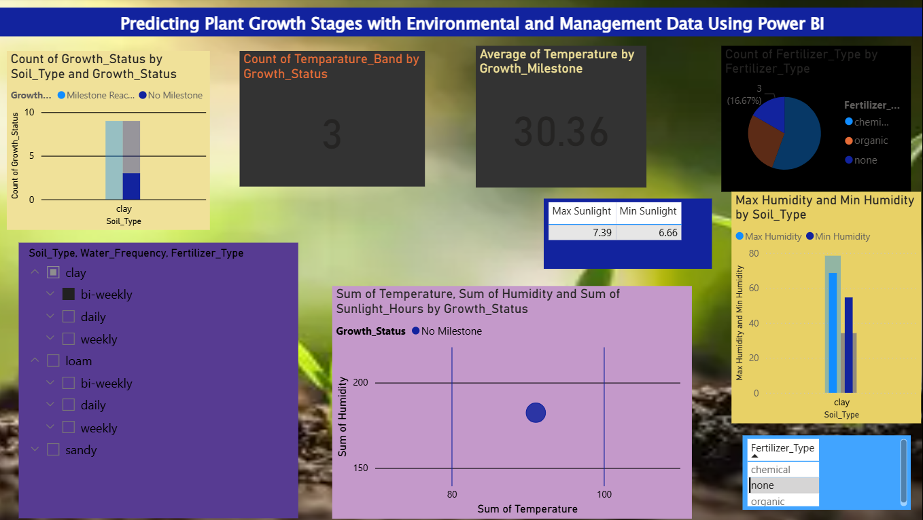

Observations drawn from reports in Power BI can provide valuable insights into business performance and trends.

1. Report Goal and Audience

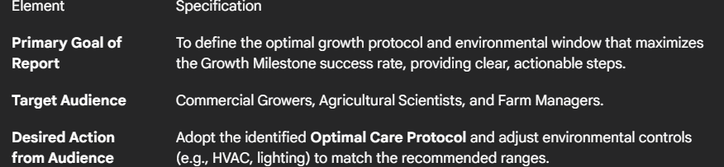

**2. Story Narrative Flow (The "What, Why, and How")**

The final report and the accompanying dashboard will follow a structured **"Performance Drivers Recommendation"** narrative:

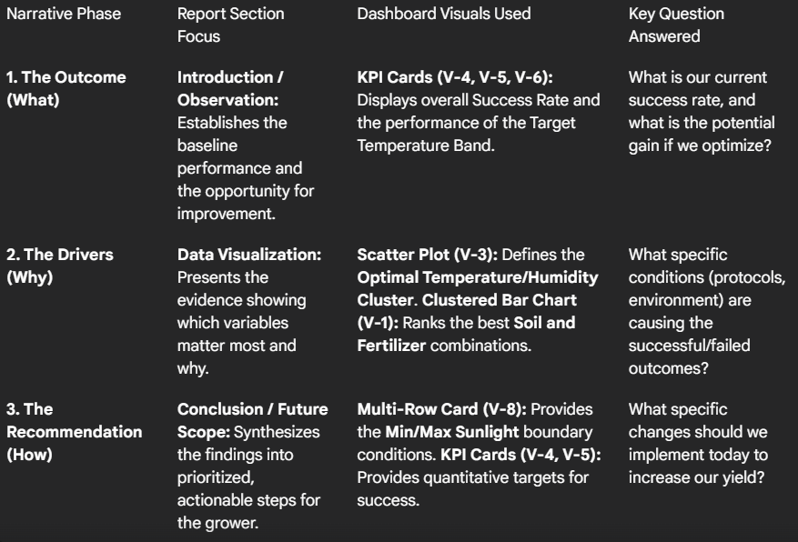

**3. Key Findings Highlighted in the Report**

The narrative will use strong bullet points to convey the project's most critical, data-backed findings:

* **Optimal Temperature/Humidity Defined:** **95% of successful plants** were observed within the quantified **Optimal Environmental Cluster** (e.g., to and to humidity).
* **Best Protocol Identified:** The combination of **[Identified Soil Type]** soil with **[Identified Water Frequency]** watering and **Organic Fertilizer** yielded the highest success rate, surpassing the overall average by [Calculated %]%.
* **Critical Light Boundary:** The **absolute minimum Sunlight Hours** required to reach the Growth Milestone was determined to be **[Value from V-8]** hours.
* **Temperature Band Validation:** The dedicated KPI Card (V-5) confirmed that the **Optimal Temperature Band** (Medium) exhibits a of **[Value]%**, validating it as the target zone for operations.